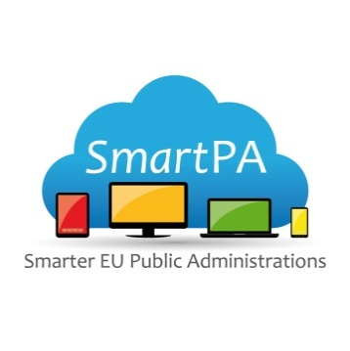 |  | 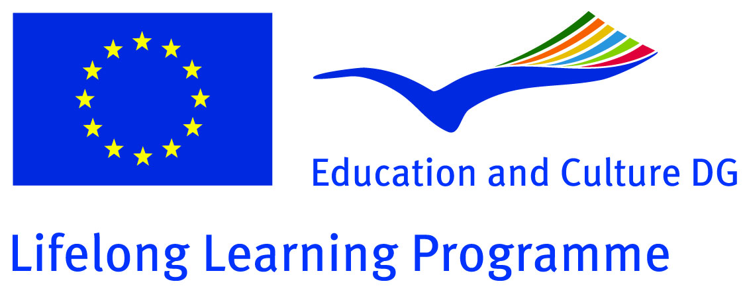  This project has been funded with support by the European Commission. This website reflects the views of the authors only and the Commission cannot be held responsible for any use which may be made of the information contained herein.

Learning Event and Kick-Off Meeting of the Project
“Smarter EU Public Administrations”
04.-06. November 2013, IAT Gelsenkirchen

PROGRAM

04. November 2013 | Arrivals and meeting at the hotel
05. November 2013 | Learning event and meeting at the IAT, Munscheidstr. 14 in Gelsenkirchen
09:30-10:30 | Welcome and short presentation of the participants
10:30-11:00 | What is cloud computing and which are the advantages for the organisations?
11:00-11:30 | Social media and social platforms
11:30-12:00 | Coffee break
12:00-13:00 | Seminar:  The use of cloud computing and social platforms in partner organisations
13:00-14:00 | Lunch
14:00-15:00 | New work plan of the project
15:00-15:30 | Coffee break
15:30-16:30 | Dissemination activities and dissemination materials
06. November 2013 | Project meeting at the hotel / IAT
10:30-11:30 | Plan and content of the meetings
11:30-12:00 | Evaluation procedures
14:00 | Cultural program
07. November 2013 | Depart of the participants

